The Impact of the Great Recession on Student Scores in Florida: Did School Ratings Matter?

Carol Dole±

Andrew Ju*
April 2023

Abstract
Previous research showed that the Great Recession of 2007-2008 had negative effects on student test scores. These declines were linked, in part, to the negative effects of states' educational budget cuts or less spending per student. Using individual student test scores, this paper examines whether the level of school quality (as measured by criterion-referenced tests) cushioned the negative effects of this decline in spending. Preliminary results show that student scores in higher-rated school districts declined as a result of the recession's cuts, but by less than lower-rated school districts.

JEL-Codes: I2, H7, E2
Keywords: Great Recession, School District Quality, Student Achievement, Education Finance, Florida

- Introduction
Following initial school finance reforms (SFR) in the 1970s, a great deal of research has addressed the effects of these changes on K – 12 students. This level of attention can partly be explained by the conclusion drawn by Coleman (1968) which reported no relationship existed between school resources and student performance on student test scores. If student performance would not be aided by additional spending on students and education, then why undertake the so-called reforms? Subsequent research aimed to explain the lack of a relationship and ranged from reasons like measuring the wrong outcome (for example, standardized test scores or adult earnings) to analyzing the impact of “adequacy” versus “equity” reforms. In each of these papers, the initial forced change in education spending in the 1960s or the subsequent reforms due to the 1989 Rose court decision provided a natural experiment with treatment groups. No consensus was reached across this collection of research.
The Great Recession (GR) of 2007-08 created a similar chance to examine an exogenous change in school funding and prompted another round of studies addressing the link between student outcomes and school spending. Much of this research focuses on the percentage of a school district’s funding drawn from local versus state levels and the extent to which this difference affected funding and student achievement (Lafortune, Rothstein and Schanzenbach, 2016; Evans, Schwab and Wagner, 2019; Jackson, 2019; Jackson, Wigger and Xiong, 2021). Results across this strand of research focus on the impact of the economic downturn on lower- versus higher-income school districts.
Following these studies, this paper aims to capture whether quality of the school district cushioned the negative effects of economic downturn on Florida students’ academic performance. Florida’s K-12 public schools are funded via the Florida Educational Finance Program (FEEP) enacted in 1973. A key feature of FEEP is that it recognizes cross-county differences in county property tax bases and costs of living which shelter each county from changes and differences in local economic conditions. Another feature of Florida schools is that school districts (in Florida’s case, counties) are rated from A to F based on criterion-referenced tests administered annually to all public school students. These test scores are used to rate districts (and the schools within them) from A to F. In addition, over this paper’s time frame the federal government enacted the American Recovery and Reinvestment Act of 2009 (ARRA) which aimed to stabilize school budgets and soften the impact of lost state- and locally-based educational funding. It’s likely that all counties’ school budgets took a hit as a result of the GR, but our results show that the impacts on low-income and high-income districts were of similar magnitudes. Using the restricted-use individual-level NAEP test score data from the National Center for Education Statistics (NCES), this paper finds that student scores in higher-rated districts declined as a result of the recession’s cuts, but by less than lower-rated school districts.
The remainder of this paper is organized with a literature review which is followed by a description of the data and regression approach used. A discussion of the results along with a conclusion tie the paper together.

Literature Review
The Coleman Report (Coleman et al., 1968) which found no relationship between educational funding and student educational performance provoked a stream of research that both supported his findings and others which looked for different explanations. Hanushek (1997) reviews over 400 studies and recognizes all of the inputs that affect student outcomes: family situation, teacher quality, school quality, etc. The paper concludes that schools “exhibit continuing inefficiency” as there are no consistent findings across these studies.
Another collection of research followed the 1989 Kentucky ruling of Rose v. CBE. Most of these papers highlight the idea that the initial changes in SFR addressed an inequality in funding while the reforms occurring in the subsequent years addressed an adequacy in funding. Card and Payne (2002) examined the impact of school finance reform and found that in states where funding had been unconstitutional, the reform fixed the spending gap resulting in a narrowing of the gap of SAT scores. Jackson, Johnson and Persico (2016) speak to problematic issues created by the exogenous changes due to court-mandated reforms versus endogenous funding changes and find that proper school funding can positively affect long-run adult outcomes. Lafortune, Rothstein and Schanzenbach (2018) focused on low-income and high-income school districts, noting the relative increase in spending for low-income districts. Using a triple-difference model, the authors confirm a positive impact of SFR in low-income districts. Candelaria and Shores (2019) show that the adequacy reforms succeeded in increasing graduation rates for the poorest students via an increase in spending per student.
Roughly fifty years since Coleman et al., another collection of papers recognizes that the Great Recession (GR) provides another chance to investigate whether a change in school funding (temporary, albeit) can be linked to changes in student performance. Shores and Steinberg (2019), using a nationwide data set from 2002 through 2015 with NAEP scores serving as proxies for student achievement, found that students in counties hardest hit by the economic downturn experienced significant declines in student achievement. Jackson, Wigger and Xiong (2021) note that while student achievement cannot consistently be linked to educational funding, spending cuts do make a difference. The authors developed a tool for measuring the size of the recessionary shock’s impact on school funding dependent on the degree to which a state relied on local versus state versus federal funding. The study found that student achievement suffers as a result of the spending cuts and these effects may be longer lasting. Jackson (2019) uses Florida in its examination of the impact of the GR on education attainment highlighting that this choice controls for the impact of any cross-state differences both in the impact of the recession on and school funding policies. The study focuses on high school and college students and finds little evidence that the economic downturn affected student outcomes.
We seek to expand on Jackson’s study in several ways. First, in contrast to Jackson (2019), our analysis implements triple differences (DDD) models, and by doing so we essentially utilize high quality school districts in low recession impacted areas as an additional control group. Second, we link the Annual Survey of School System Finances (F-33) to examine whether spending patterns differed across districts with different ratings. Finally, we use restricted-use individual level test score data to examine whether the impact of the recession translated into differences in student achievement depending on the quality of school districts.

- Data
We assemble data from various sources for our analysis. The first source is the school district rating data from the Florida Department of Education. The original purpose of the rating system was to inform parents and the public how well each school is serving its students. The district grading is based on four broader components: 1) student achievement in English Language Arts (ELA), math, social studies, and science, 2) middle school acceleration, 3) graduation rate, 4) and college and career acceleration. Each school district receives a grade of A, B, C, D, or F annually and for this study, we assign each district a value of 4 if the district received a grade of “A” and subtract a value of one for each lower letter grade. Our final school quality measure is based on the average of district ratings over the 5-years prior to the start of the Great Recession. Figure 1A presents a map showing overall school district ratings by five tiers.
We supplement this data with Local Education Agency (School District) Finance Survey (F-33) administered by the National Center for Education Statistics (NCES). F-33 is a large-scale survey data that provides detailed annual revenue and expenditure data for all school districts in the United States. Based on NCES school district identification number (LEAID), we combine the finance data with dataset containing information on school student demographic characteristics using NCES Common Core of Data (CCD), from which we construct a measure for average class size using the total district enrollment and the number of full-time equivalent teachers (FTE) for each school district.
To examine how school district quality during the Great Recession affected student achievement, we utilize restricted-use individual level National Assessment of Educational Progress (NAEP) from the NCES. The NAEP is a nationally representative data set that includes student achievement in math and reading assessments of fourth and eighth grade public school students in each state. It is often referred to as the “Nation’s Report Card”, because it is the only test score data comparable across states and years. We focus on 4th and 8th-grade mathematics and reading scores because the two tests were administered every two years between 2003 and 2015. Finally, we merge in county population, median household income, fraction Black, fraction Hispanic, school-aged population, and child poverty rates.
Table 1 presents summary statistics for the key variables for all districts combined, dividing the districts into high-rated (above median) and low-rated (below median) districts. On average, districts high ratings have a higher total population but lower child poverty rates and student-teacher ratios. The proportion of non-white students, LEP (Limited English Proficient), and SPED (Special Education Program) students are smaller in the high-rated school districts.

Empirical Strategy
In order to understand the relationship between district quality and outcomes, we begin by estimating a differences-in-differences (DD) model that takes the following form:
$$\left(1\right) Y_{dt}= β_{0}+β_{1}\left({Rating}_{d}*{GR}_{t}\right)+πZ_{dt}+δ_{d}+λ_{t}+ε_{dt}$$
where $Y_{dt}$ is the district-level outcome of interest, that includes various categories of per-pupil expenditures, full-time teacher employment and the student-to-teacher ratio for district $d$ in year $t$. ${GR}_{t}$ is a post-Great Recession indicator variable for the years 2008 and beyond. $πZ_{dt}$ is a vector of district-level characteristics such as share of free lunch eligible students, share of students in Individualized Education Plan, share of students in English Language Program, and share of Black, Hispanic, and Asian students. $δ_{d}$ represents a district fixed effect to account for any district specific time invariant (observable and unobservable) characteristics. $λ_{t}$ represents year fixed effect. Note that because Equation (1) includes district and year fixed effects, the level effects of ${Rating}_{d}$ and ${GR}_{t}$ are omitted. The key parameter of interest in Equation (1), $β_{1}$, measures the difference-in-differences effect associated with a one-tier higher district ratings, post-Great Recession.
An immediate concern arises that school districts with different level of quality ratings may have been differentially impacted by the recession. For example, financial disruptions may have been concentrated in counties with low median household income, thus leading to deteriorating outcomes for the students who enrolled in financially disadvantaged school districts. To address such concerns, we make use of a third level of variation, which represents the magnitude of recessionary shock measured by the county specific unemployment rate. By incorporating this third difference that incorporates the severity of recessionary shock, we essentially utilize high quality school districts in low-recession-impacted areas as an additional control group. Specifically, we estimate the following regression:
$$\left(2\right) Y_{dt}= α_{0}+{α_{1}Unemp}_{dt}+α_{2}\left({Unemp}_{dt}*{GR}_{t}\right)+α_{3}\left({Rating}_{d}*{GR}_{t}\right)$$
$$+α_{4}\left({Unemp}_{d}*{Rating}_{d}*{GR}_{t}\right)+πZ_{dt}+δ_{d}+λ_{t}+ε_{dt},$$
where ${Unemp}_{dt}$ is the district-level unemployment rate standardized to have a mean zero and standard deviation (SD) of one. The key parameter of interest in Equation (2) is $α_{3}$, which represents how the DD effect $(α_{2})$ changes for school districts facing large recessionary effects. Note that the total effect of the Great Recession for otherwise similar districts with higher ratings is represented by $α_{2}+α_{3}$.
Finally, to examine the differential impact of the Great Recession on student achievement, we modify our model by replacing the dependent variable with individual-level student test scores from the National Assessment of Educational Progress. Formally, we estimate a DDD model of the following form:
$$\left(3\right) {NAEP}_{idt}= γ_{0}+γ_{1}{Unemp}_{dt}+γ_{2}\left({Unemp}_{dt}*{GR}_{t}\right)+γ_{3}\left({Rating}_{d}*{GR}_{t}\right)$$
$$+γ_{4}\left({Unemp}_{dt}*{Rating}_{d}*{GR}_{t}\right)+πZ_{dt}+ρX_{idt}+δ_{d}+λ_{t}+ε_{idt},$$
where ${NAEP}_{idt}$ represents NAEP math or reading scores for student $i$, in district $d$ during year $t$. In addition to controls and fixed effects mentioned in Equation (2), we include a set of student demographics, which includes gender, race, IEP status, and LEP status. We also standardize all NAEP test scores. Like Equation (2), the main coefficient of interest in this model is $γ_{3}$, which indicates how student performances were impacted by the recession depending on the quality of the school district.

- Results
We begin by presenting the results from DD models provided by Equation (1) to examine whether district quality had any impact on school district spending patterns. All specifications are weighted by district enrollment and standard errors are clustered at the district level to allow for within-district autocorrelation of the disturbance term. Furthermore, all regressions in Table 2 include the full set of district controls, district fixed effects, and year fixed effects.
Columns 1, 3, and 5 of Table 2 report results for district expenditure categories, namely total revenue, current expenditures, and capital outlays. The estimated DD coefficients reported in column 1 are small and statistically insignificant, indicating that districts with different ratings did not experience any differential impact on per-pupil total and current spending post-GR. Turning to the result presented in column 5, we find that higher-district quality is associated with a statistically significant 8.6 percentage point decrease in per-pupil capital outlays spending. Albeit capital outlay expenditures account for less than 10% of total spending, this provides evidence that when faced with a spending cut, school districts are much more likely to reduce capital spending on the margin. Regarding effects on non-financial outcomes, columns 7 and 9 of Table 2 report results based on Equation (1), replacing the dependent variable with student-to-teacher ratio (class size) and log of full-time teacher employment, respectively. We find a small decrease in class size of 0.2 students per teacher associated with district quality. Similarly, we find no evidence of impacts on teacher employment, with an insignificant positive estimate of 0.01 log points. This is not surprising given the findings on total and current expenditures.
One potential concern with the results based on Equation (1) is that we are essentially assuming the recession impacted all districts equally. As a result, the findings above do not necessarily reflect the true variation of the recessionary shock. To address this potential concern, we implement the triple-differences model that utilized the unemployment rate as a proxy for the magnitude of local recessionary shock. Columns 2, 4, 6, 8, and 10 present results from the estimation of Equation (2). While the estimated coefficient for ${Unemp}_{dt}×{GR}_{t}$ in column 2 suggests an increase in unemployment was associated with a decrease in per-pupil spending, the DDD estimates of ${Unemp}_{dt}×{GR}_{t}×{Rating}_{d}$ indicate that there is a small and statistically insignificant relationship between school quality and education spending pattern. One potential explanation for the null impact on spending is that ARRA went into effect in 2009, and funds were distributed to districts using formulas based primarily on population and student poverty rates. Nevertheless, we find no evidence that the recession led to differential impact on spending across districts with various levels of district quality.
We next examine whether student performance during the recession varied depending on the quality of school districts. The results based on the estimation of Equation (3) are reported in Table 3. In these models, we include a set of student demographic controls in addition to the controls and fixed effects mentioned in Equation (2). Columns 1-4 reports results for NAEP math and NAEP reading. The DD regression results presented in the first column of each subjects demonstrate that district quality had no impact on student achievement during the Great Recession.
However, the DDD estimates reveal that there exist substantial heterogeneous effects of school district quality. Specifically, we find that a one standard deviation increase in district quality is associated with a differential effect of a 0.04 SDs and 0.03 SDs in NAEP Math and NAEP reading, respectively. Drilling down to each subject by grade, columns 5 through 12 show the pattern of results generally persists across all individual assessments, though we lose statistical precision for them. For instance, the DDD estimate reported in column 6 indicates that student performance in 4th grade math score in high-rated districts increased by about 0.045 SDs, but marginally statistically significant at the 5 percent level. Despite this, the positive and statistically significant estimates indicate that achievement gap between students in high quality vs. low-quality districts widened, especially in the areas that were hit the hardest by the recession.

- Conclusion
This paper examined the impact of the Great Recession on student achievement in Florida school districts using students’ NAEP test scores. The paper was also focused on whether the quality of the school district (as rated by the state) played a role in this impact. Noting that educational budgets were negatively affected during the recession, the results that student scores in all districts declined, but the scores for students in more highly-rated districts were less negatively impacted compared to student scores in lower-rated districts.

References
Card, David and Alan Krueger. 1996. School resources and student outcomes: An overview of the literature and new evidence from North and South Carolina. Journal of Economic Perspectives 10(4): 31-50.

Card, David and Alan Krueger. 1997. Class size and earnings-Response." Journal of Economic Perspectives 11(4): 226-227

Card, David and A. Abigail Payne. 2002. School finance reform, the distribution of school spending, and the distribution of student test scores. Journal of Public Economics, 83(1): 49-82.

Coleman, James. 1968. Equality of educational opportunity. Integrated education 6(5):19-28.

Evans, William, Robert Schwab, and Kathryn Wagner. 2019. The Great Recession and public education. Education Finance and Policy, 14(2): 298-326.

Hanushek, Eric. 1997. Assessing the effects of school resources on student performance: An update. Educational Evaluation and Policy Analysis 19(2): 141-164.

Jackson, Kirabo, Rucker Johnson, and Claudia Persico. 2016. The effects of school spending on educational and economic outcomes: Evidence from school finance reform. The Quarterly Journal of Economics, 131(1): 157-218.

Jackson, Paul. 2019. “The Impact of the Great Recession on Educational Attainment: Evidence from Florida”, Working Paper.

Jackson, C. Kirabo, C. O. R. A. Wigger, and H. E. Y. U. Xiong. "The costs of cutting school spending." Education Next 20.4 (2020).

Lafortune, Julien, Jesse Rothstein, and Diane Whitmore Schanzenbach. 2018. School finance reform and the distribution of student achievement." American Economic Journal: Applied Economics, 10(2): 1-26.

Lubienski, Sarah and Christopher Lubienski. 2006. School sector and academic achievement: A multilevel analysis of NAEP mathematics data. American Educational Research Journal, 43(4): 651-698.

Shores, Kenneth and Matthew Steinberg. 2019. Schooling during the Great Recession: Patterns of school spending and student achievement using population data. AERA Open, 5(3): 2332858419877431. https://doi.org/10.1177/2332858419877431.

Figure 1: 2004-2008 Average District Grades
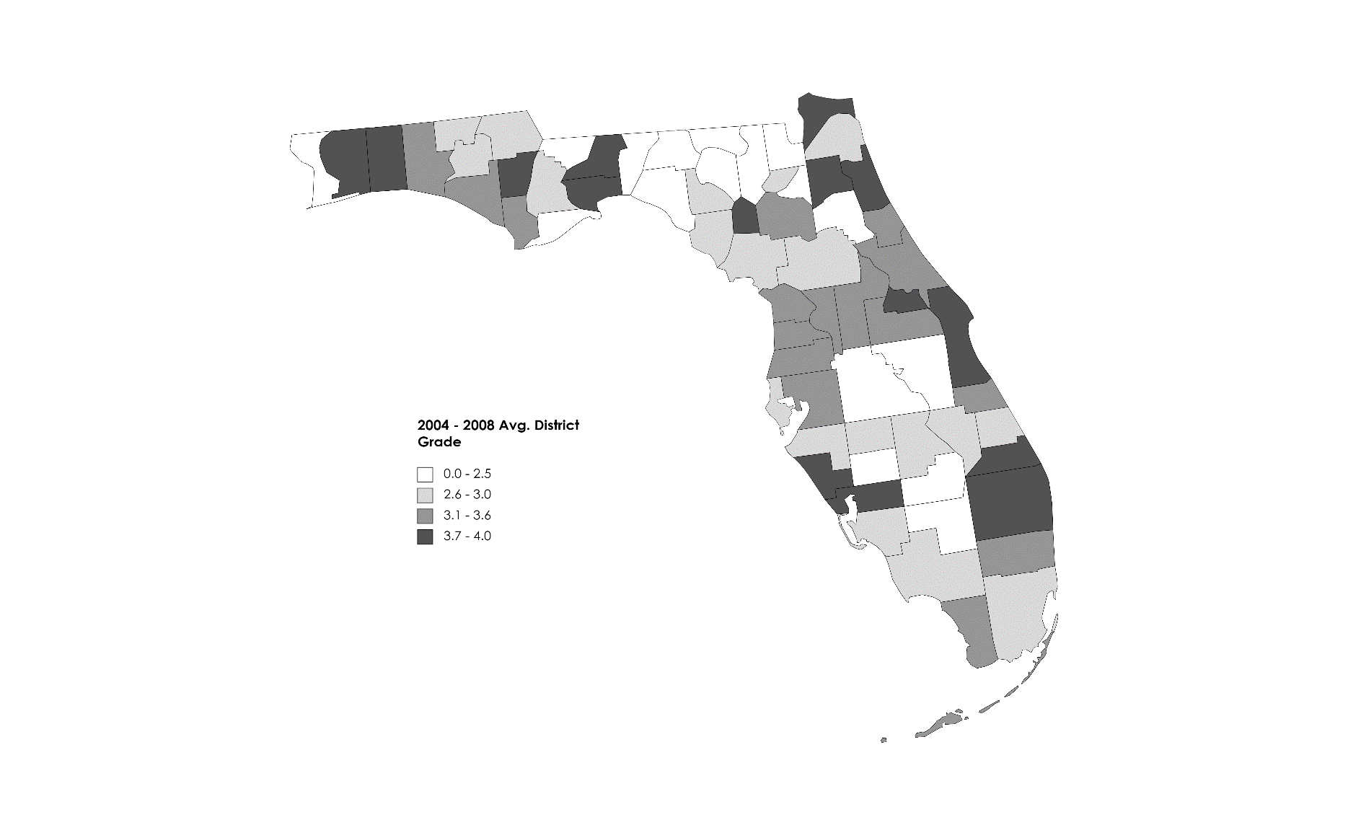
Notes: Map shows 2004-2008 average school district grades. Data obtained from the Florida Department of Education – Florida School Accountability Reports. https://www.fldoe.org/accountability/accountability-reporting/school-grades/
Figure 2: 2008-2009 Unemployment Rate
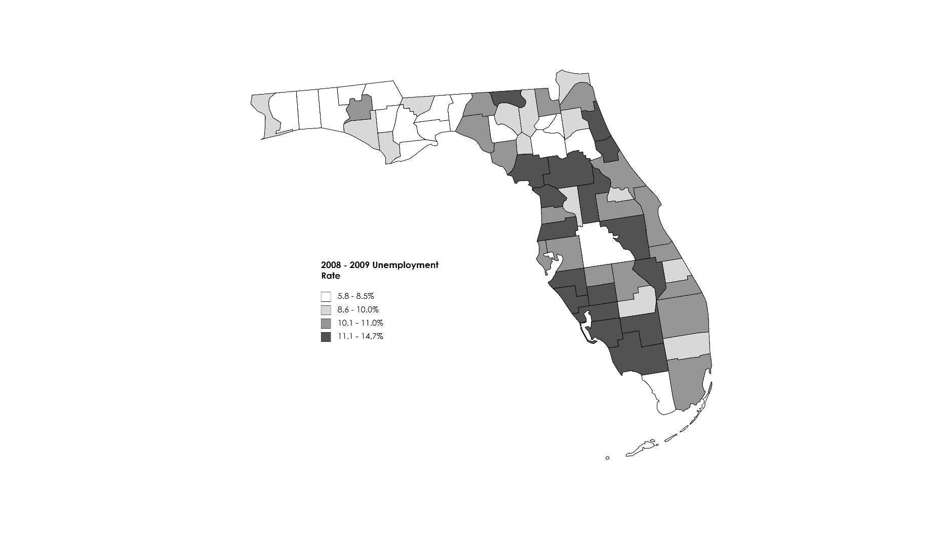
Notes: Map shows school districts by 2008-2009 average district unemployment rate. Data obtained from the Bureau of Labor Statistics (BLS) - Local Area Unemployment Statistics (LAUS) website:

Table 1: Summary Statistics by District Ratings
 | Full Sample |  | High-Rated Districts |  | Low-Rated Districts
 | Mean | Std. Dev. | Mean | Std. Dev. | Mean | Std. Dev.
Per-Pupil Spending (District)
Total Expenditure | 9,512 | 2,071 | 9,451 | 1,869 | 9,564 | 2,233
Total Current Expenditure | 8,057 | 1,376 | 7,847 | 1,344 | 8,238 | 1,381
Total Capital Outlay | 1,161 | 1,300 | 1,265 | 991 | 1,071 | 1,513
Other District Level Variables
District Population | 275,850 | 441,373 | 338,481 | 424,502 | 221,917 | 449,168
School Age Population | 43,488 | 72,227 | 53,169 | 71,109 | 35,152 | 72,265
Child Poverty Rate | 0.22 | 0.07 | 0.18 | 0.05 | 0.25 | 0.06
District Enrollment | 39,219 | 64,108 | 48,156 | 63,052 | 31,524 | 64,119
Fraction Female Student | 0.48 | 0.01 | 0.48 | 0.01 | 0.48 | 0.01
Fraction Asian Students | 0.01 | 0.01 | 0.02 | 0.01 | 0.01 | 0.01
Fraction Black Students | 0.19 | 0.15 | 0.15 | 0.10 | 0.23 | 0.17
Fraction Hispanic Students | 0.14 | 0.15 | 0.12 | 0.09 | 0.17 | 0.17
Fraction LEP Students | 0.04 | 0.04 | 0.04 | 0.04 | 0.05 | 0.05
Fraction SPED Students | 0.16 | 0.03 | 0.16 | 0.03 | 0.17 | 0.04
Pupil-Teacher Ratio | 15.90 | 2.18 | 15.98 | 2.43 | 15.84 | 1.94
Full Time Equivalent Teachers | 2,426.17 | 3,849.72 | 3021.76 | 3898.25 | 1913.30 | 3738.69
Observations | 536 |  | 248 |  | 288
Note: Summary statistics for district level revenue and expenditure variables are from the 2002-2015 District Finance Survey (F-33) Data maintained by National Center for Education Statistics (NCES). Student achievement data come for the 2002-2015 National Assessment of Educational Progress (NAEP)

Table 2: Effects on School District Spending/Class Size/Number of Teachers
 | (1) | (2) | (3) | (4) | (5) | (6) | (7) | (8) | (9) | (10)
VARIABLES | log_totexp | log_totexp | log_curexp | log_curexp | log_capexp | log_capexp | ptratio_p | ptratio_p | log_fte | log_fte
Rating × GR | -0.00571 | -0.00503 | 0.000497 | -0.000614 | -0.0857* | -0.0894* | -0.215* | -0.235 | 0.0113 | 0.0164*
 | (0.00694) | (0.00805) | (0.00326) | (0.00383) | (0.0443) | (0.0516) | (0.127) | (0.148) | (0.00833) | (0.00969)
Unemp |  | 0.0893*** |  | 0.00287 |  | 0.410* |  | 1.783*** |  | -0.0746*
 |  | (0.0331) |  | (0.0157) |  | (0.212) |  | (0.604) |  | (0.0399)
Unemp × GR |  | -0.0678** |  | -0.00928 |  | -0.369** |  | -1.074** |  | 0.0722**
 |  | (0.0291) |  | (0.0139) |  | (0.187) |  | (0.533) |  | (0.0351)
Unemp × GR × Rating |  | 0.000278 |  | 0.000742 |  | 0.00342 |  | 0.0961 |  | -0.00696
 |  | (0.00563) |  | (0.00268) |  | (0.0361) |  | (0.102) |  | (0.00678)
District Controls | x | x | x | x | x | x | x | x | x | x
Observations | 355 | 355 | 355 | 355 | 355 | 355 | 323 | 323 | 355 | 355
R-squared | 0.893 | 0.894 | 0.973 | 0.973 | 0.738 | 0.742 | 0.697 | 0.700 | 0.996 | 0.996
Notes: Data from the District Finance Survey Data (F-33) and Common Core of Data (CCD) 2002-2015. Each column presents results from a separate regression where the dependent variable is listed in the column headers. Rating is the average school district rating in between 2004-2008, Unemp is the average unemployment rate in between 2008-2009, and Rec is a dummy variable equal to 1 if the observation is after 2007. All specifications include fraction female students, fraction Asian students, fraction Hispanic students, fraction Black students, fraction SPED students, fraction LEP students, district fixed effects, and year fixed effects. All specifications are weighted by district enrollment. Robust standard errors in parentheses and clustered at the district and state-year level. *** p<0.01, ** p<0.05, * p<0.1

Table 3: Effects on Student Achievement
 | (1) | (2) | (3) | (4) | (5) | (6) | (7) | (8) | (9) | (10) | (11) | (12)
VARIABLES | Math | Math | Reading | Reading | GR4 Math | GR4 Math | GR8 Math | GR8 Math | GR4 Reading | GR4 Reading | GR8 Reading | GR8 Reading
Rating × GR | -0.0100 | -0.00169 | 0.0109 | -0.0528 | -0.0151 | 0.0815 | 0.00189 | -0.115** | 0.0277 | 0.00137 | -0.00380 | -0.120
 | (0.0146) | (0.0777) | (0.0173) | (0.112) | (0.0203) | (0.144) | (0.0166) | (0.0467) | (0.0206) | (0.170) | (0.0230) | (0.0722)
Unemp |  | -0.0879 |  | -0.0909 |  | -0.135 |  | -0.0218 |  | -0.109 |  | -0.0574
 |  | (0.0559) |  | (0.114) |  | (0.119) |  | (0.0540) |  | (0.183) |  | (0.100)
Unemp × GR |  | -0.0486 |  | -0.0240 |  | -0.0606* |  | -0.0302 |  | 0.00348 |  | -0.0463
 |  | (0.0256) |  | (0.0246) |  | -0.0268 |  | (0.0295) |  | (0.0343) |  | (0.0268)
Unemp × GR × Rating |  | 0.0398*** |  | 0.0321*** |  | 0.0445** |  | 0.0419* |  | 0.0158 |  | 0.0498**
 |  | (0.00903) |  | (0.00831) |  | (0.0120) |  | (0.0179) |  | (0.0134) |  | (0.0143)
Student Controls |  | x |  | x |  | x |  | x |  | x |  | x
District Controls |  | x |  | x |  | x |  | x |  | x |  | x
Observations | 67,720 | 67,720 | 73,840 | 73,840 | 36,760 | 36,760 | 30,960 | 30,960 | 40,030 | 40,030 | 33,810 | 33,810
R-squared | 0.186 | 0.187 | 0.184 | 0.184 | 0.212 | 0.213 | 0.154 | 0.155 | 0.192 | 0.192 | 0.169 | 0.170
Notes: Analysis based on restricted-use individual-level NAEP test scores from the NCES. Each column presents results from a separate regression where the dependent variable is listed in the column headers. All test scores are normalized to mean zero with standard deviation of one. All columns include controls for student characteristics, district fixed effects and year fixed effects. Robust standard errors in parentheses and clustered at the district and state-year level. *** p<0.01, ** p<0.05, * p<0.1

± Professor of Economics and Sport Business, Jacksonville University, Jacksonville, FL. Email: cdole@ju.edu.
*Assitant Professor of Economics, Jacksonville University, Jacksonville, FL. Email: aju@ju.edu. Acknowledgement: We thank participants at the 2022 Academy of Economics & Finance Conference for their helpful comments and suggestions. Thank you to Taara Cason and Brandy Blake-Hicks at IES for assistance with the NAEP data.
For example, Card and Krueger (1996) studies time in school, Card and Krueger (1997) analyzes adult earnings, while Card and Payne (2002) examine the impact on SAT scores. Hanushek (1986) addresses achievement gains resulting from the initial “equity” reforms. Lafortune, Rothstein and Schanzenbach (2016) review the differences in gains due to changes in school funding due to “adequacy” reforms.
Evans, Schwab and Wagner (2019) do not directly examine the effect of the GR on academic performance, but showed that the school districts located in states that used proportionately more school funding from state income and sales taxes faced a larger exposure to economic downturns. It also reports that funding during the GR differed from other economic downturns. It took about 16 months for school funding to return to previous levels of funding when compared to other recessions when funding changes either did not occur or were shorter-lived.
According to the Florida department of education, school Grading Scale: A = 62% of points or greater, B = 54% to 61% of points, C = 41% to 53% of points, D = 32% to 40% of points, F = 31% of points or less. https://www.fldoe.org/core/fileparse.php/18534/urlt/SchoolGradesOverview21.pdf
These variables include share of free lunch eligible students, share of students in Individualized Education Plan, share of students in English Language Program, and share of Black, Hispanic, and Asian students.
The NAEP test scores used in this paper starts from 2003 because the sample size increased 10 times larger than any previous NAEP administration (Lubienski and Lubienski, 2006)
Based on NBER recession dates, which indicates that the Great Recession began during the 4th quarter of 2007. http://www.nber.org/cycles.html
These controls include gender, race, individualized educational plan (IEP) status, and limited English proficiency (LEP) status.

